December 2020

Diehl delivers ammunition for frigate F125

The signing of a basic agreement on production and delivery of 127 mm practice ammunition for the frigates of the type "Baden-Württemberg" (F125) allows Diehl to introduce a new naval ammunition on the market. In addition, the ammunition family comprises high-explosive (HE) and illuminating (ILL) projectiles including appropriate propellant charges.
The delivery of the practice ammunition pilot lot is scheduled to start as of 2021, followed by several production lots in the period from 2022 to 2025, with a total of 7,000 projectiles. Given the fact that further deliveries are possible, the number of total pieces could increase to 13,000 projectiles in the context of the ongoing agreement that runs until 2027.
The high-explosive ammunition is still in qualification at the Bundeswehr technical center 91 in Meppen. The completion of the performance proof is expected by next year. Thanks to the combination with the improved propellant charge, the new ammunition family allows for a significantly extended range of the naval gunnery. In conjunction with the use of an insensitive explosive, the design of the service ammunition prevents unintended reaction (detonation), e.g. in case of enemy shelling or fire on board. This contributes to the protection of the crew and provides on board safety. Moreover, the high-explosive ammunition will be equipped with a multi-functional fuze of the Italian industry partner Leonardo.
The illuminating ammunition for battlefield illumination, for which Diehl Defence is cooperating with the Spanish industry partner EXPAL, is currently in qualification as well.

About Diehl Defence
Diehl Defence concentrates the Diehl Group’s business activities in the fields of security and defence. As a parent company, Diehl Defence controls numerous subsidiaries, program and affiliated companies. Diehl Defence generates annual sales of 560 million euros with 2,700 employees.
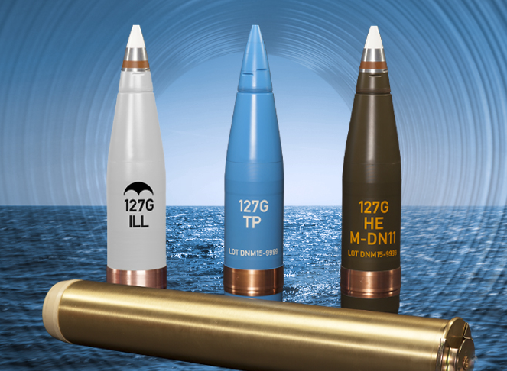

Image (Diehl Defence): The new 127 mm ammunition family in full-caliber (f.l.) with illuminating (ILL), practice (Üb) and high-explosive projectiles including propellant charge (horizontal)
________________________________________________________________________________________________

