Raytheon Anschütz Selected as INS Provider for Government of Canada’s OFSV

Thales, a major system integrator in Canada, has chosen Raytheon Anschütz as the supplier of the Integrated Navigation System (INS) for the Canadian Coast Guard’s (CCG) new Offshore Fisheries Science Vessels (OFSV).

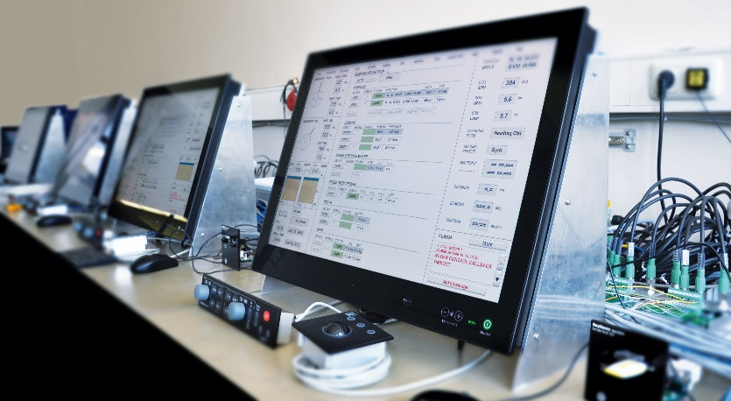
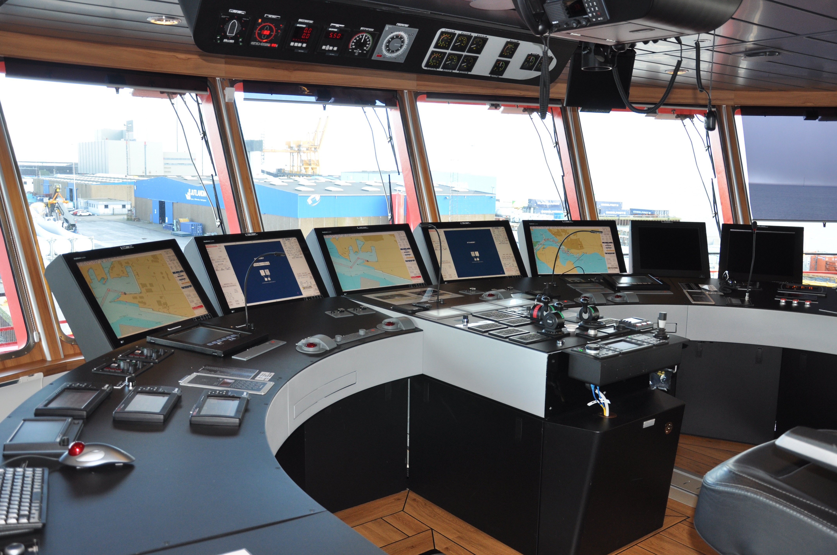As part of the OFSV program, three new vessels are being built for the CCG at Seaspan’s world-class, state-of-the-art Vancouver Shipyards – the most modern facility of its size in North America. The 63-metre vessels are designed to operate in the Atlantic, Pacific and Arctic Oceans. Their mission profile is to conduct fishing and acoustic surveys and collect oceanographic data to monitor changes in the ecosystem. Seaspan is the Government of Canada’s National Shipbuilding Strategy (NSS) Non-Combat capability provider and is responsible for building the next generation of Non-Combat vessels for the CCG and RCN.

Under the contract, Raytheon Anschütz provides the customer with a Canadian version of their globally proven Synapsis Intelligent Bridge Control system. The new OFSVs are equipped with advanced Synapsis Integrated Navigation Systems.

The INS features five Synapsis NX multifunctional workstations for radar, ECDIS and conning for the main bridge console. Further multifunctional workstations are supplied for installation at the bridge wings, for the aft fishing and starboard stations, and as chart station. The workstations are based on ultra-compact and powerful Small Marine Computers which serve as the standard hardware platform for all bridge applications. All workstations receive and share data through the Ethernet network, where sensor integration is simplified with the versatile NautoPlex data collectors. This enhances flexibility and reduces complexity in system design and cabling.

To further enhance the interoperability of ship systems and reach a higher degree of integration, the Synapsis INS decouples central services from individual applications and concentrates them on an innovative infrastructure software framework which follows service oriented architecture and is built entirely on a stack of open source solutions and standard industrial components. The INS framework provides functional integration of AIS, charts, radar, centralized target management and alarm management, system health status display and reliability indication for important sensors. The alarm management is enhanced to display alarms generated by the Ship Control and Monitoring Systems (SCMS). The INS also integrates an onboard training simulator to provide simulated data for the Factory Acceptance Test (FAT).

The navigation system is fitted with the advanced NP 5400 autopilot system which offers customized algorithms for precise cruising and trawling operations as well as low speed side operations. The navigation system also includes a redundant gyro compass system featuring the maintenance-free Horizon MF sensors, and the new generation of NautoScan NX network radar transceivers. The NautoScan NX transceivers generate a raw radar video, which is distributed via Gigabit LAN without any analogue losses, enabling optimized performance for end-user applications.

Raytheon Anschütz, in cooperation with their long-term service partner Imtech Radio Holland Canada, will also provide training to Thales in Canada and Vancouver Shipyards and technical support during factory acceptance test, setting-to-work and sea acceptance test, as well as ongoing maintenance and support as needed during operation.

Raytheon Anschütz has proven references with the Royal Canadian Navy, among others through the delivery of navigation radars to the Halifax Cass modernization program and INS to ORCA class training vessels.

Picture:

- As one of the world’s most experienced navigation system integrators, Raytheon Anschütz will deliver an IMO-compliant advanced Integrated Navigation System (INS) to the Canadian OFSV program.
- Typical Synapsis installation

Note for the editor:

About Raytheon Anschütz

Raytheon Anschütz GmbH is a subsidiary of the Raytheon Company and a leading integrator of maritime systems such as bridge and navigation systems for all kinds of commercial vessels and naval ships, or maritime and coastal surveillance systems. More than 35,000 vessels worldwide are equipped with Raytheon Anschütz navigation systems, backed with a global network of owned subsidiaries and regional offices, e.g. in Shanghai, Singapore, Rio de Janeiro, Panama, San Diego, and Portsmouth / UK, as well as with a network of specialized service stations around the world. More information: http://www.raytheon-anschuetz.com

About Raytheon

Raytheon Company, with 2015 sales of $23 billion and 61,000 employees, is a technology and innovation leader specializing in defense, civil government and cybersecurity solutions. With a history of innovation spanning 94 years, Raytheon provides state-of-the-art electronics, mission systems integration, C5ITM products and services, sensing, effects, and mission support for customers in more than 80 countries. Raytheon is headquartered in Waltham, Mass. Visit us at www.raytheon.com and follow us on Twitter @Raytheon.

